Product Drawing | Unit Tag:
  
  Software Version:
Product: Variable Frequency Drive | Project Name:
Model: 033ALC | Sales Office:
Sales Engineer: | Date: | Ver/Rev: | Sheet 1 of 3 | Scale: N/A | Tolerance: N/A | Dwg Units: N/A
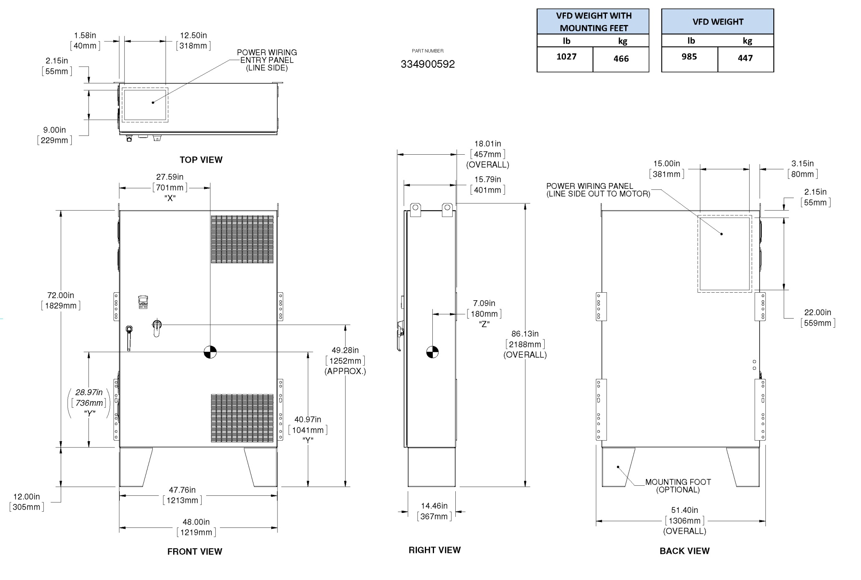
0A
033ALC (Cabinet 2)

